**Name – Kamal D. Agrahari TE IT - A | Batch – B**

**ID – VU4F2223028 Subject – IP Lab**

Experiment No. 2 – A

**Aim:** Design a web page using CSS font and text properties

**Program**:

<!DOCTYPE html>

<html lang="en">

<head>

<meta charset="UTF-8" />

<meta name="viewport" content="width=device-width, initial-scale=1.0" />

<link rel="stylesheet" href="font.css" />

<title>CSS Font properties</title>

</head>

<body>

<header class="header">CSS Font and Text Properties</header>

<hr />

<label for="font-family">Font-Family</label>

<p id="font-family">

Lorem ipsum dolor sit amet, consectetur adipiscing elit. Sed do eiusmod

tempor incididunt ut labore et dolore magna aliqua. Ut enim ad minim

veniam, quis nostrud exercitation ullamco laboris nisi ut aliquip ex ea

commodo consequat.

</p>

<hr />

<label for="font-size">Font-Size</label>

<p id="font-size">

Lorem ipsum dolor sit amet, consectetur adipiscing elit. Sed do eiusmod

tempor incididunt ut labore et dolore magna aliqua. Ut enim ad minim

veniam, quis nostrud exercitation ullamco laboris nisi ut aliquip ex ea

commodo consequat.

</p>

<hr />

<label for="font-weight">Font-Weight</label>

<p id="font-weight">

Lorem ipsum dolor sit amet, consectetur adipiscing elit. Sed do eiusmod

tempor incididunt ut labore et dolore magna aliqua. Ut enim ad minim

veniam, quis nostrud exercitation ullamco laboris nisi ut aliquip ex ea

commodo consequat.

</p> <hr />

<label for="font-style">Font-Style</label>

<p id="font-style">

Lorem ipsum dolor sit amet, consectetur adipiscing elit. Sed do eiusmod

tempor incididunt ut labore et dolore magna aliqua. Ut enim ad minim

veniam, quis nostrud exercitation ullamco laboris nisi ut aliquip ex ea

commodo consequat.

</p>

<hr />

<label for="font-variant">Font-Variant</label>

<p id="font-variant">

Lorem ipsum dolor sit amet, consectetur adipiscing elit. Sed do eiusmod

tempor incididunt ut labore et dolore magna aliqua. Ut enim ad minim

veniam, quis nostrud exercitation ullamco laboris nisi ut aliquip ex ea

commodo consequat.

</p>

<hr />

<label for="font-stretch">Font-Stretch</label>

<p id="font-stretch">

Lorem ipsum dolor sit amet, consectetur adipiscing elit. Sed do eiusmod

tempor incididunt ut labore et dolore magna aliqua. Ut enim ad minim

veniam, quis nostrud exercitation ullamco laboris nisi ut aliquip ex ea

commodo consequat.

</p>

<hr />

<label for="color">Color</label>

<p id="color">

Lorem ipsum dolor sit amet, consectetur adipiscing elit. Sed do eiusmod

tempor incididunt ut labore et dolore magna aliqua. Ut enim ad minim

veniam, quis nostrud exercitation ullamco laboris nisi ut aliquip ex ea

commodo consequat.

</p>

<hr />

.

<label for="text-align">Text-Align</label>

<p id="text-align">

Lorem ipsum dolor sit amet, consectetur adipiscing elit. Sed do eiusmod

tempor incididunt ut labore et dolore magna aliqua. Ut enim ad minim

veniam, quis nostrud exercitation ullamco laboris nisi ut aliquip ex ea

commodo consequat

</p>

<hr />

<label for="text-decoration">Text-Decoration</label>

<p id="text-decoration">

Lorem ipsum dolor sit amet, consectetur adipiscing elit. Sed do eiusmod

tempor incididunt ut labore et dolore magna aliqua. Ut enim ad minim

veniam, quis nostrud exercitation ullamco laboris nisi ut aliquip ex ea

commodo consequat

</p>

<hr />

<label for="text-transform">Text-Transform</label>

<p id="text-transform">

Lorem ipsum dolor sit amet, consectetur adipiscing elit. Sed do eiusmod

tempor incididunt ut labore et dolore magna aliqua. Ut enim ad minim

veniam, quis nostrud exercitation ullamco laboris nisi ut aliquip ex ea

commodo consequat.

</p>

<hr />

<label for="text-indent">Text-Indent</label>

<p id="text-indent">

Lorem ipsum dolor sit amet, consectetur adipiscing elit. Sed do eiusmod

tempor incididunt ut labore et dolore magna aliqua. Ut enim ad minim

veniam, quis nostrud exercitation ullamco laboris nisi ut aliquip ex ea

commodo consequat

</p>

<hr />

<label for="line-height">Line-Height</label>

<p id="line-height">

Lorem ipsum dolor sit amet, consectetur adipiscing elit. Sed do eiusmod

tempor incididunt ut labore et dolore magna aliqua. Ut enim ad minim

veniam, quis nostrud exercitation ullamco laboris nisi ut aliquip ex ea

commodo consequat.

</p>

<hr />

<label for="letter-spacing">Letter-Spacing</label>

<p id="letter-spacing">

Lorem ipsum dolor sit amet, consectetur adipiscing elit. Sed do eiusmod

tempor incididunt ut labore et dolore magna aliqua. Ut enim ad minim

veniam, quis nostrud exercitation

</p><hr />

<label for="word-spacing">Word-Spacing</label>

<p id="word-spacing">

Lorem ipsum dolor sit amet, consectetur adipiscing elit. Sed do eiusmod

tempor incididunt ut labore et dolore magna aliqua. Ut enim ad minim

veniam, quis nostrud exercitation ullamco laboris nisi ut aliquip ex ea

commodo consequat

</p>

<hr />

<label for="text-shadow">Text-Shadow</label>

<p id="text-shadow">

Lorem ipsum dolor sit amet, consectetur adipiscing elit. Sed do eiusmod

tempor incididunt ut labore et dolore magna aliqua. Ut enim ad minim

veniam, quis nostrud exercitation ullamco laboris nisi ut aliquip ex ea

commodo consequat.

</p>

<hr />

<label for="white-space">White-Space</label>

<p id="white-space">

Lorem ipsum dolor sit amet, consectetur adipiscing elit. Sed do eiusmod

tempor incididunt ut labore et dolore magna aliqua. Ut enim ad minim

veniam, quis nostrud exercitation ullamco laboris nisi ut aliquip ex ea

commodo consequat.

</p>

</html>

**font.css**

*,

*::after,

*::before {

margin: 0;

padding: 0;

box-sizing: border-box;

}

body {

padding: 0 20px;

}

.header {

text-align: center;

font-size: 26px;

padding: 10px 0;

}

hr {

margin: 10px 0;

}

label {

font-size: 18px;

padding: 15px;

}

p {

padding: 16px;

}

#font-family {

font-family: "Comic Sans MS";

}

#font-size {

font-size: 12px;

}

#font-weight {

font-weight: 700;

}

#font-style {

font-style: italic;

}

#font-variant {

font-variant: small-caps;

}

#font-stretch {

font-stretch: ultra-expanded;

}

#color {

color: cadetblue;

}

#text-align {

text-align: right;

}

#text-decoration {

text-decoration: line-through;

}

#text-transform {

text-transform: uppercase;

}

#text-indent {

text-indent: 30px;

}

#line-height {

line-height: 1.5;

}

#letter-spacing {

letter-spacing: 5px;

}

#word-spacing {

word-spacing: 15px;

}

#text-shadow {

text-shadow: 2px 2px 5px rgba(0, 0, 0, 0.3);

}

#white-space {

white-space: nowrap;

}

**Output**

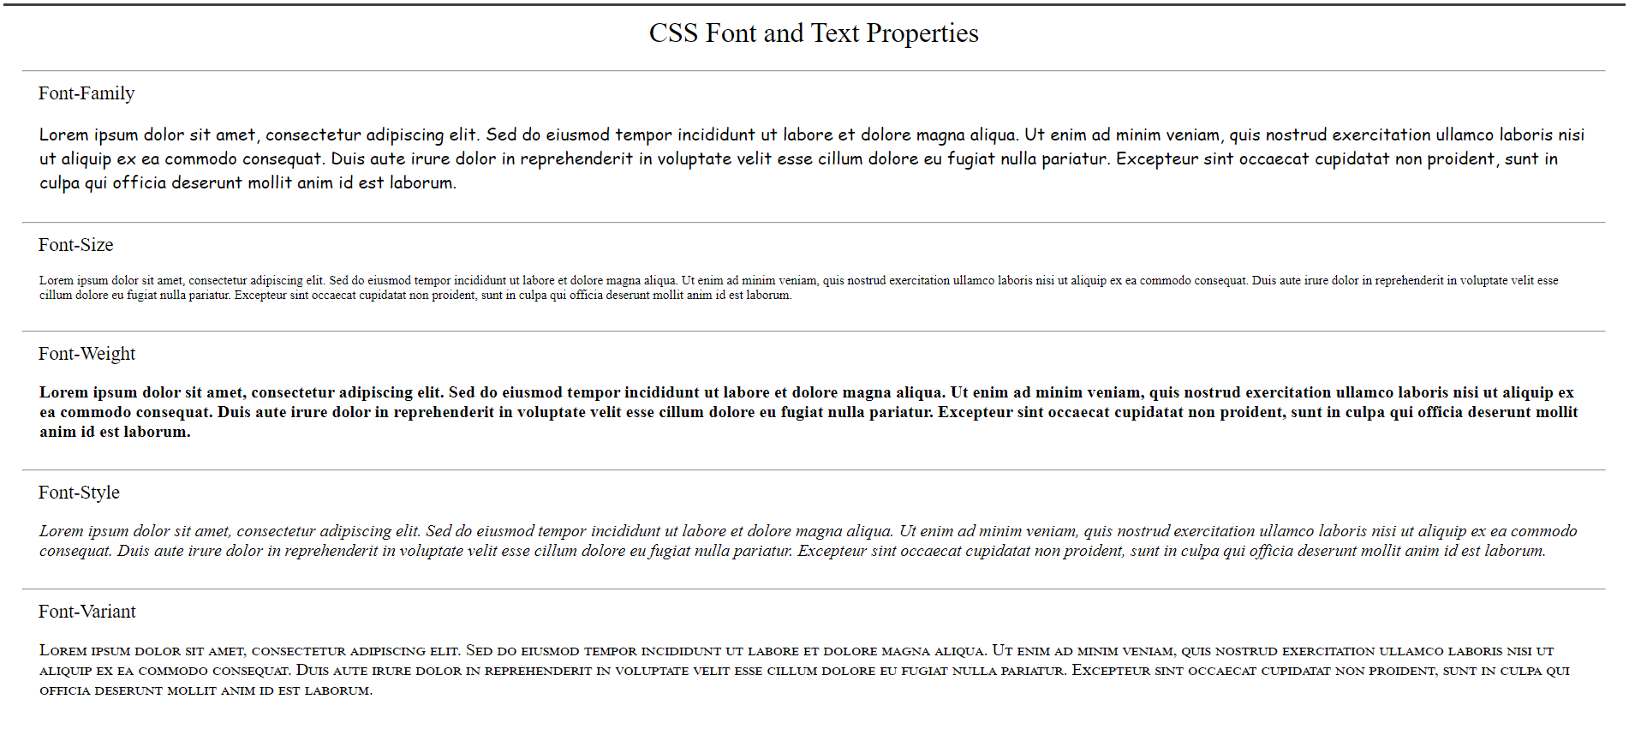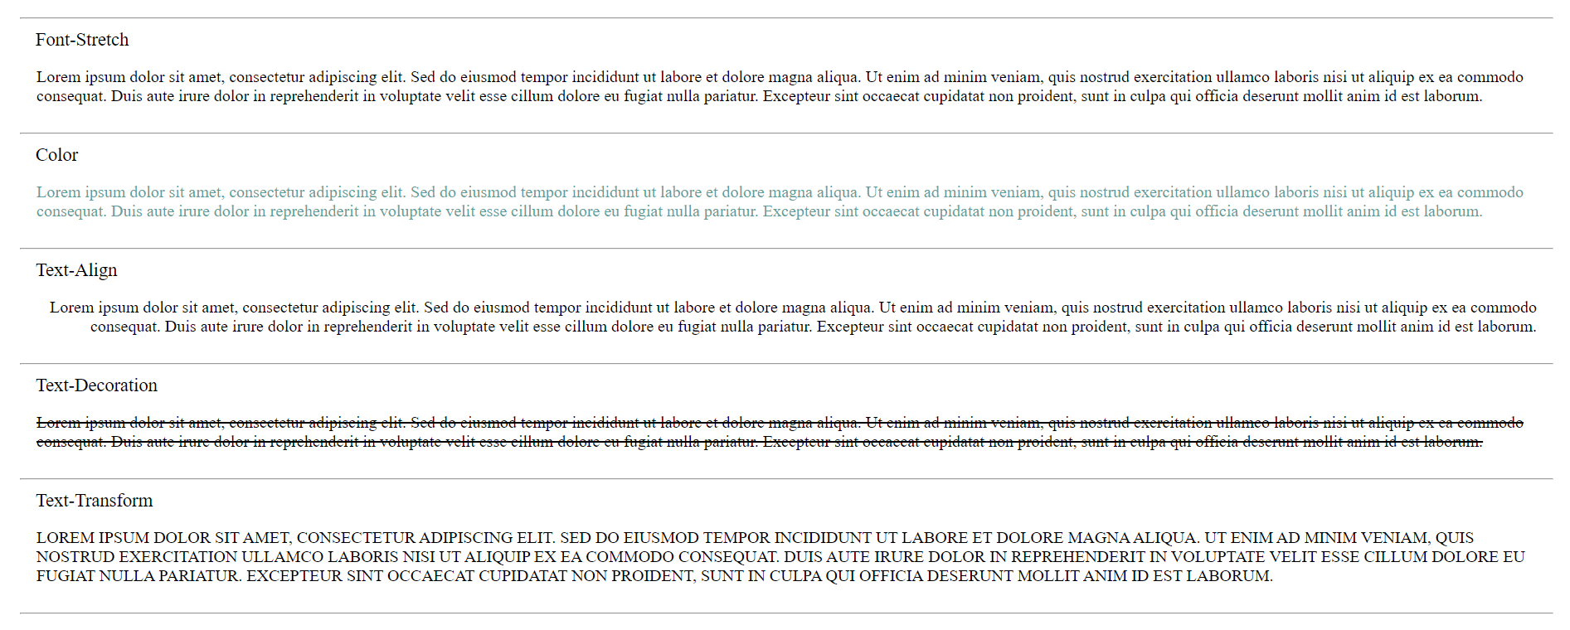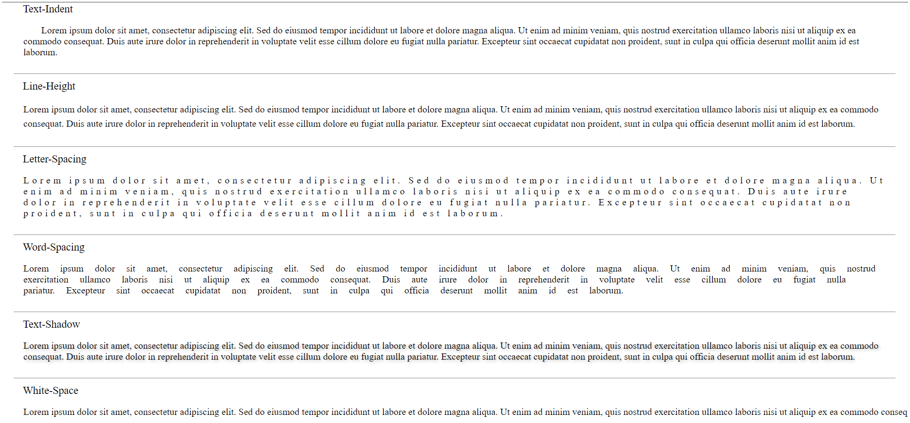

Experiment No. 2 – B

**Aim:** Design a web page using CSS background properties

Program

<!DOCTYPE html>

<html lang="en">

<head>

<meta charset="UTF-8" />

<meta name="viewport" content="width=device-width, initial-scale=1.0" />

<link rel="stylesheet" href="background.css" />

<title>CSS Background Properties</title>

</head>

<body>

<header>

<p>CSS Background Properties</p>

</header>

<div class="grid-box">

<div id="background-color"><p>Background Color</p></div>

<div id="background-image"><p>Background Image</p></div>

<div id="background-position"><p>Background Position</p></div>

<div id="background-size"><p>Background Size</p></div>

<div id="background-repeat"><p>Background Repeat</p></div>

<div id="background-origin"><p>Background Origin</p></div>

<div id="background-clip"><p>Background Clip</p></div>

<div id="background-attachment"><p>Background attachment</p></div>

<div id="background-blend-mode"><p>Background Blend Mode</p></div>

</div>

</body>

</html>

**Background .css**

* {

margin: 0;

padding: 0;

box-sizing: border-box;

}

header {

font-size: 22px;

padding: 15px 0;

text-align: center;

}

.grid-box {

display: grid;

grid-template-columns: repeat(3, 1fr);

gap: 20px;

padding: 50px;

justify-items: center;

}

.grid-box div {

width: 200px;

height: 200px;

border-radius: 15px;

}

.grid-box div p {

color: rgb(237, 233, 233);

text-shadow: -1px -1px 0 #000, 1px -1px 0 #000, -1px 1px 0 #000,

1px 1px 0 #000;

font-size: 18px;

text-align: center;

background-color: aliceblue;

margin: 50% 0;

}

#background-color {

background-color: aqua;

}

#background-image {

background-image: url(background-img.jpeg);

}

#background-position {

background-image: url(background-img.jpeg);

background-position: center;

}

#background-size {

background-image: url(background-img.jpeg);

background-size: contain;

}

#background-repeat {

background-image: url(small-img.jpg);

background-size: 65px;

background-repeat: repeat;

}

#background-origin {

background-image: url(small-img.jpg);

background-origin: unset;

}

#background-clip {

background-image: url(background-img.jpeg);

background-clip: content-box;

}

#background-attachment {

background-image: url(background-img.jpeg);

background-attachment: fixed;

}

#background-blend-mode {

background-image: url(background-img.jpeg), url(small-img.jpg);

background-blend-mode: exclusion;

}

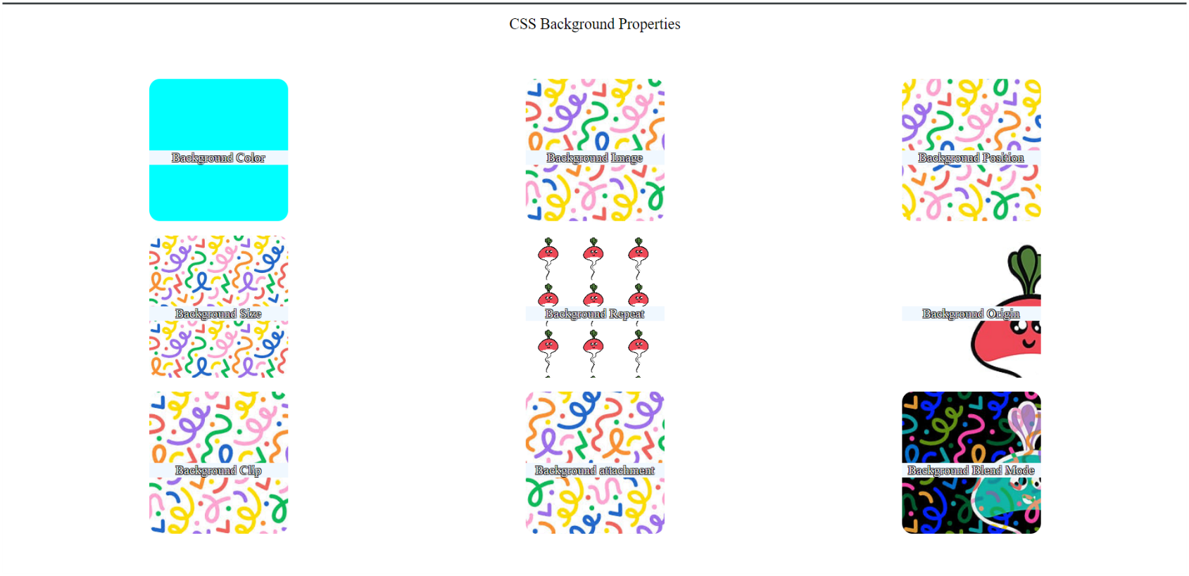**Output**